**Tool & Technique Laboratory (T&T Lab.)**

**[CS-3096]**

**Individual Work**

**Lab. No:1 , Date: 17-01-2023 , Day:TUESDAY**

**Topic:**

|  |  |  |  |
| --- | --- | --- | --- |
| **Roll Number:** | **200** | **Branch/Section:** | **cse/17** |
| **Name in Capital:** |  | | |

**(Instruction:** Rename this file as r-LAB-x where r is your roll number & x is your lab. number & Suppose your roll number is 1905123 & you want to submit lab-2 programs, then file name should be 1905123-LAB-2. Finally delete all texts inside parentheses, also parenthesis)

**Program No: (**1.1)

**Program Title:**

(Write here your program title in detail)

1. WAP to subtract a number from another number and display the result.

**Input/Output Screenshots:**

**RUN-1:**

(Paste here the screenshots of first run)

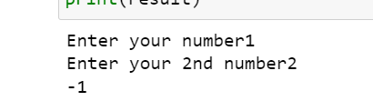

**RUN-2**

(Paste here the screenshots of second run )

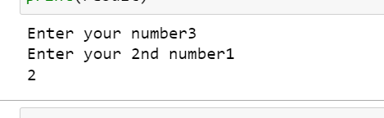

**Source code**

(Paste here the source code)

**#WAP to subtract a number from another number and display the result.**

**a=int(input('Enter your number'))**

**b=int (input('Enter your 2nd number'))**

**result =a-b ;**

**print(result)**

**Conclusion/Observation**

Successfully subtract a number from another number

—---------------------------------------------------------------------------------------------------------------------------

**Program No: (**1.2)

**Program Title:**

(Write here your program title in detail)

2 WAP to convert temperature from centigrade to Fahrenheit scale.

**Input/Output Screenshots:**

**RUN-1:**

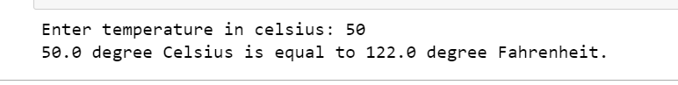

**Input/Output Screenshots:**

**RUN-2**

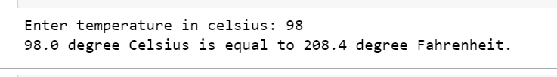

**Source code**

(Paste here the source code)

**celsius = float(input("Enter temperature in celsius: "))**

**fahrenheit = (celsius * 1.8) + 32**

**print(str(celsius )+ " degree Celsius is equal to " + str(fahrenheit )+ " degree Fahrenheit.")**

**Conclusion/Observation**

Successfully convert temperature from centigrade to Fahrenheit scale

— — — — — — — — — — — — — — — — — — — — — — — — — — — — — — — — —

**Program No: (**1.3)

3.)WAP to calculate perimeter of a circle.

Run 1 :

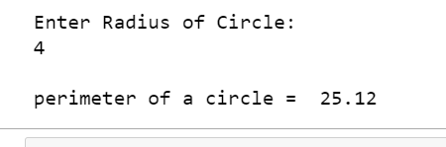

Run 2 :

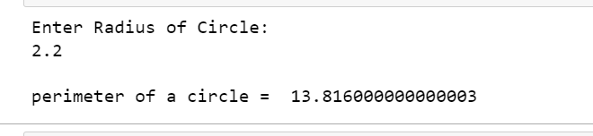

**Source code :**

p**rint("Enter Radius of Circle: ")**

**r = float(input())**

**pie = 3.14**

**c = 2 * pie * r**

**print("\nperimeter of a circle = ", c)**

**Conclusion/Observation**

Successfully calculate perimeter of a circle

—-------------------------------------------------------------------------------------------------------------------

**Program No: (**1.4)

**Program Title:**

(Write here your program title in detail)

4. WAP to calculate area of a triangle whose three sides are given.

**Input/Output Screenshots:**

**RUN 1**

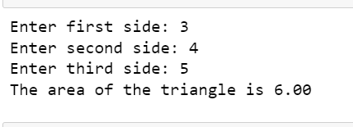

**RUN 2**

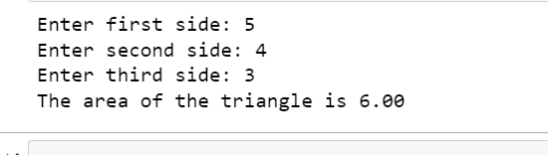

**Source code :**

**# Three sides of the triangle is a, b and c:**

**a = float(input('Enter first side: '))**

**b = float(input('Enter second side: '))**

**c = float(input('Enter third side: '))**

**# calculate the semi-perimeter**

**s = (a + b + c) / 2**

**# calculate the area**

**area = (s*(s-a)*(s-b)*(s-c)) ** 0.5**

**print('The area of the triangle is %0.2f' %area)**

**Conclusion/Observation**

Successfully calculate area of a triangle whose three sides are given

—---------------------------------------------------------------------------------------------------------------------------

**Program No: (**1.5)

5.)WAP to swap two integer numbers without using third variable.

**Input/Output Screenshots:**

**RUN 1**

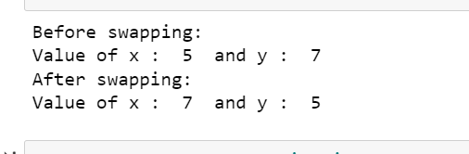

**RUN 2**

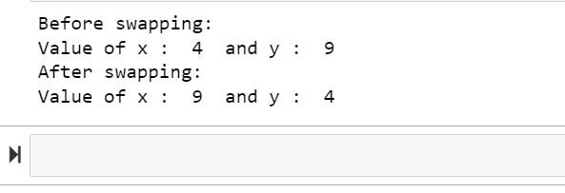

**Source code :**

**#5 #WAP to swap two integer numbers without using third variablee**

**x = 4**

**y = 9**

**print ("Before swapping: ")**

**print("Value of x : ", x, " and y : ", y)**

**# code to swap 'x' and 'y'**

**x, y = y, x**

**print ("After swapping: ")**

**print("Value of x : ", x, " and y : ", y)**

**Conclusion/Observation**

Successfully swap two integer numbers without using third variablee

—--------------------------------------------------------------------------------------------------------------------------

**Program No: (**1.6)

6.)WAP to convert a quantity in meter entered through keyboard into its equivalent kilometer andmeteras per the following format. Example. 2430 meter = 2 Km and 430 meter

**Input/Output Screenshots:**

**RUN 1**

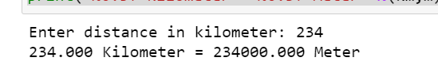

**RUN 2**

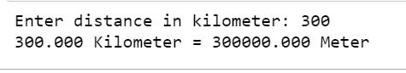

**Souce code**

**# 6 python program to convert km to m**

**# Reading input**

**km = input("Enter distance in kilometer: ")**

**# Converting to float data type**

**km = float(km)**

**# Converting to meter**

**m = km * 1000;**

**print("%0.3f Kilometer = %0.3f Meter" %(km,m))**

**Conclusion/Observation**

Successfully WAP to convert a quantity in meter entered through keyboard into its equivalent kilometer and meteras

—---------------------------------------------------------------------------------------------------------------------------

**Program No: (**1.7)

**Program Title:**

WAP to find the average mark of 5 subjects of a student and find the percentage. Assumefull markofeach subject is 100.

**Input/Output Screenshots:**

**RUN 1**

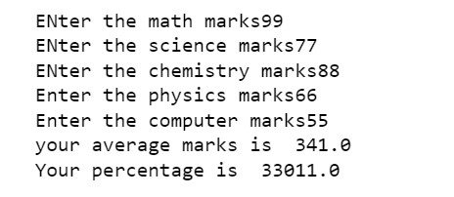

**Run 2**

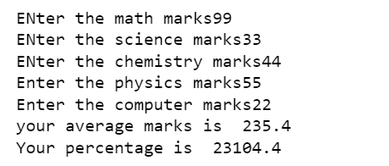

**Souce code**

**m= float(input("ENter the math marks"))**

**s= float(input("ENter the science marks"))**

**c= float(input("ENter the chemistry marks"))**

**p = float(input("Enter the physics marks"))**

**com= float(input("Enter the computer marks"))**

**Average = float(m+s+c+p+com/5 )**

**percentage = float((m+s+c+p+com/500)*100)**

**print("your average marks is ",Average)**

**print("Your percentage is ",percentage)**

**Conclusion/Observation**

Successfully average mark of 5 subjects of a student and find the percentage. Assumefull markofeach subject is 100.

—---------------------------------------------------------------------------------------------------------------------------

**Program No: (**1.8)

**Program Title:**

WAP swap the contents of two variables by using a single statement for swap in C.

**Input/Output Screenshots:**

**RUN 1**



**RUN 2**



**Source code**

**x = 22**

**y = 555**

**x, y = y, x**

**print("After Swapping values of x and y are", x, y)**

**Conclusion/Observation**

Successfully swap the contents of two variables by using a single statement

—-------------------------------------------------------------------------------------------------------------------

**Program No: (**1.9)

**Program Title:**

**9.)** WAP to add two times in hour, minitue & second format entered through the keyboardintheformathh:mm:ss

**Input/Output Screenshots:**

**RUN 1**

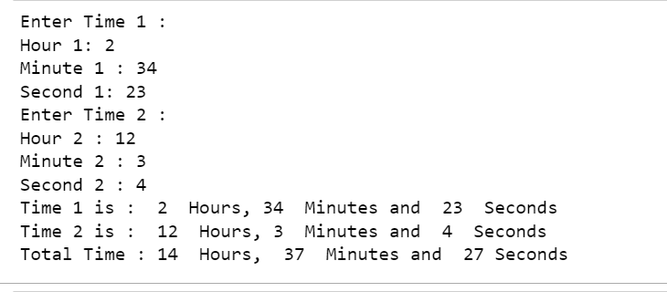

**RUN 2**

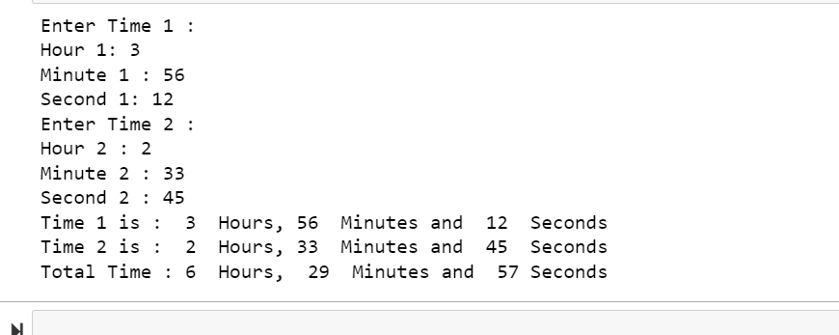

**Source code**

print("Enter Time 1 :")

h1=int(input("Hour 1: "))

m1=int(input("Minute 1 : "))

s1=int(input("Second 1: "))

print("Enter Time 2 :")

h2=int(input("Hour 2 : "))

m2=int(input("Minute 2 : "))

s2=int(input("Second 2 : "))

h3=h1+h2+(m1+m2+(s1+s2)//60)//60

m3=(m1+m2+(s1+s2)//60)%60

s3=(s1+s2)%60

print("Time 1 is : ",h1," Hours,",m1," Minutes and ",s1," Seconds")

print("Time 2 is : ",h2," Hours,",m2," Minutes and ",s2," Seconds")

print("Total Time :",h3," Hours, ",m3," Minutes and ",s3,"Seconds")

**Conclusion/Observation**

Successfully add two times in hour, minitue & second format entered through the keyboardintheformathh:mm:ss

**Program No: (**1.10)

**Program Title:** WAP to input any two integers distinct and display the greater of two integers

**Input/Output Screenshots:**

**RUN 1**



**RUN 2**



**Source code**

def maximum(a, b):

if a >= b:

return a

else:

return b

# Driver code

a = 2

b = 6

print(maximum(a, b))

**Conclusion/Observation**

Successfully input any two integers distinct and display the greater of two integers

—-----------------------------------------------------------------------------------------------------------------

**Program No: (**1.11)

**Program Title:** WAP to input any three integers distinct and display the greater of three integers

**Input/Output Screenshots:**

**RUN 1**

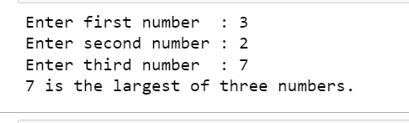

**RUN 2**

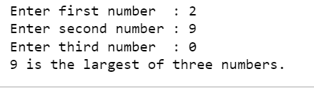

**Source code**

a = int(input('Enter first number : '))

b = int(input('Enter second number : '))

c = int(input('Enter third number : '))

largest = 0

if a > b and a > c :

largest = a

elif b > c :

largest = b

else :

largest = c

print(largest, "is the largest of three numbers.")

**Conclusion/Observation**

Successfully compile any three integers distinct and display the greater of three integers

—---------------------------------------------------------------------------------------------------------------------------

**Program No: (**1.12)

**Program Title:**WAP to test whether a number entered through keyboard is ODD or EVEN

**Input/Output Screenshots:**

**RUN 1**

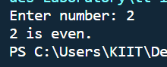

**Run 2**

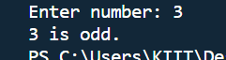

**Source code**

**# Test whether number is odd or even**

**a = int(input("Enter number: "))**

**if a & 1:**

**print(f"{a} is odd.")**

**else:**

**print(f"{a} is even.")**

**Conclusion/Observation**

Successfully compile to test whether a number entered through keyboard is ODD or EVEN

—--------------------------------------------------------------—----------------------------------------------------------